Installing Management Pack for Team Foundation Server 2008 for System Center Operations Manager 2007
Release 1, 11/15/2008

This Installation guide refers to Team Foundation Server 2008 Management Pack (MP) for System Center Operations Manager 2007 release 1 published in November 2008. For sake of brevity, we are going to refer to this product as Team Foundation Server MP in this document.

Install Procedure

PRE-REQUISITES

For the TFS MP to be deployed and used the following prerequisites must be met.
System Center Operations Manager 2007 (OpsMgr) infrastructure must be in place. This means OpsMgr Root Management Server (RMS) and the OpsMgr must be installed in addition to Agents which must be deployed on each of the servers that need to be monitored. Despite support for agent-less monitoring, it is recommended to have an agent on each managed node. It is also advised to have an Operator Console for doing administrative tasks.
If you have installed a previous version in the MP, we recommend deleting this before installing the new Version.
The Team Foundation Server 2008 MP requires the following additional MPs:
- SQL 2005 MP
- ASP.NET 2007 MP.
The complete list is shown below.
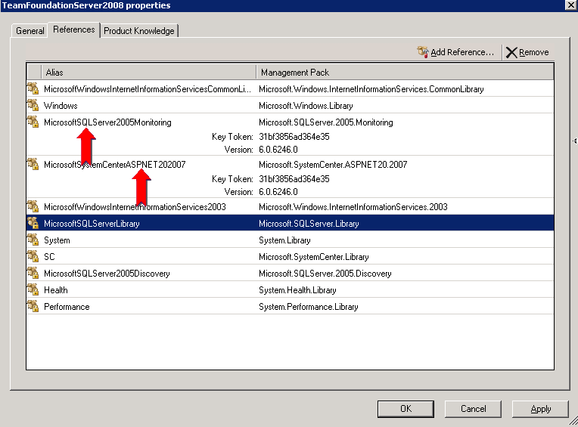

STEPS TO INSTALL THE MP
Prior to installing the MP, a “Run As Account” should be created which has privileges to access Team Foundation Server. Any valid Team Foundation Server user account can be used for this purpose.

Creating a “Run As Account”:
Go to the Operator Console and open the Administration pane. Expand the Security Node, then select “Run As Accounts”. Right Click “Run As Accounts” and choose “Create Run As Account” to launch the wizard. The account used should have privileges to access Team Foundation Server. Any valid Team Foundation Server user account will suffice. The steps to create a “Run As Account” are shown below.

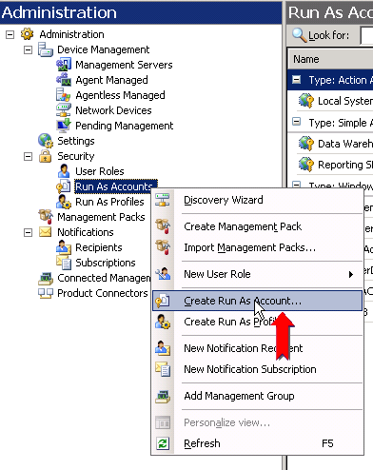

Select “Create Run As Account” and follow the steps in the wizard to create the “Run as Account”.

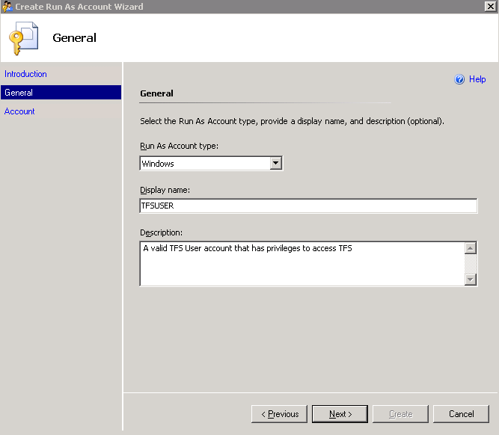

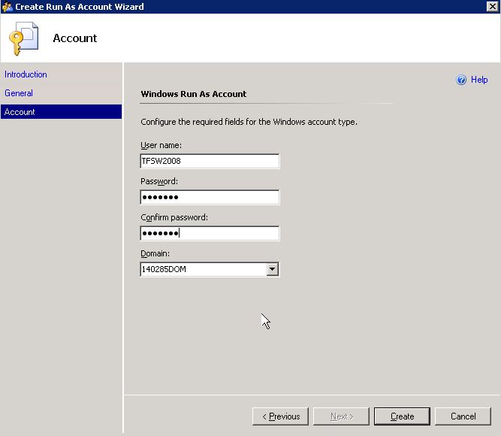

At the end of creating an account, you should see the new account in the “Run As Account” pane of the operator console as shown below.
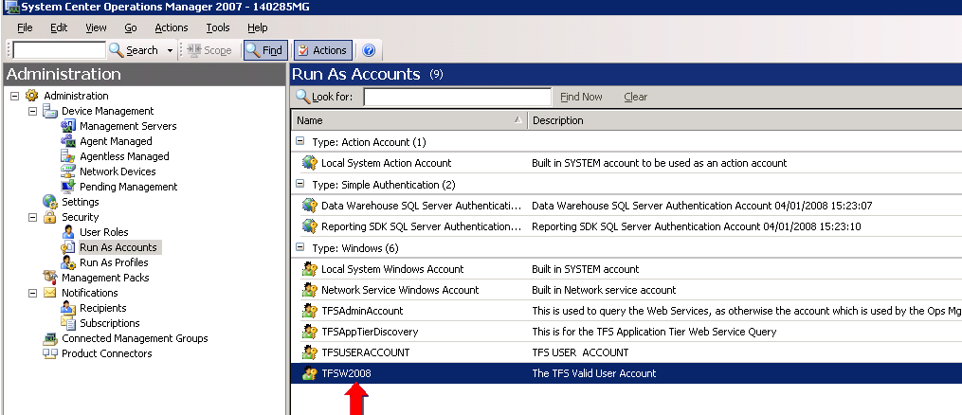

Installing the Team Foundation Server MP.
The next step is to install the MP. The install steps are very simple. If not already installed, import the dependencies outlined at the beginning of this document namely SQL 2005 MP and ASP.NET 2007 MP into the Management Console. This can be done by copying the sealed Team Foundation Server MP into a known location and importing the Team Foundation Server 2008 MP from that location via the “Import Management Packs” option in the Management Console. If there are any other dependent references, they must be imported before Team Foundation Server MP.
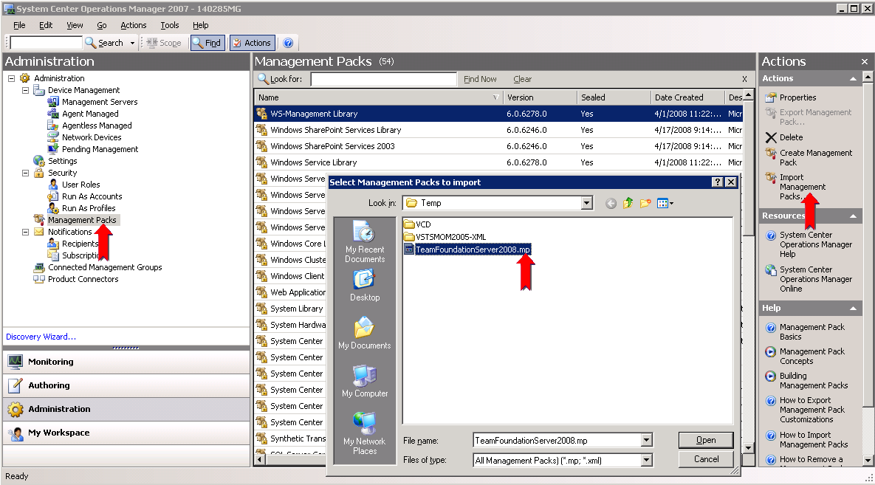

Configure the “TFSUSerProfile” :
Go the Admin Pane of the Operator Console and wire up the "TFS User Profile" with the "Run As Account" created in the earlier step and also choose the hosts on which that privilege is required. Note that this privilege is required only on the machines in which the Application Tier is present.
T

Associate the “Run As Account” to the “TFSUserProfile”

Once the MP has been imported, the next step is to create the association between the “Run As Account” created earlier with the “TFSUserProfile” in the MP. The steps to do this are shown below.
Go to the Administration Pane in the Ops Console and Right Click on the “Run As Profiles” node. You should see the TFSUserProfile in the middle pane as shown below. If it does not appear, Right Click on Run As Profiles and hit “Refresh”.
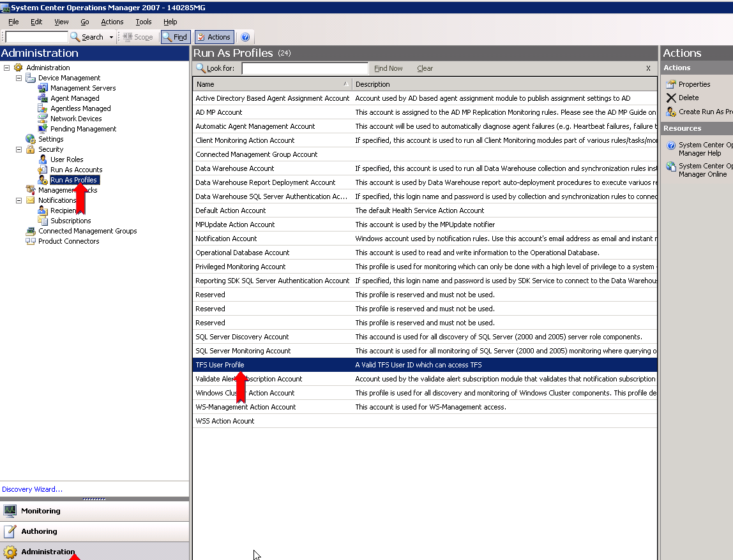

Double click the “TFS User Profile” Once it is visible. Add the machines on which you want this association to be exercised. These are Team Foundation Server application tier hosts. You can determine which hosts are Team Foundation Server application tier hosts by looking in the Monitoring pane of the Ops console and opening up the “View of Team Foundation Server application tiers”.

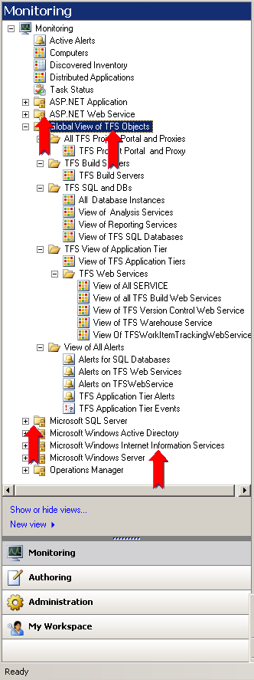
Make the association for those Team Foundation Server application tier hosts as shown below.
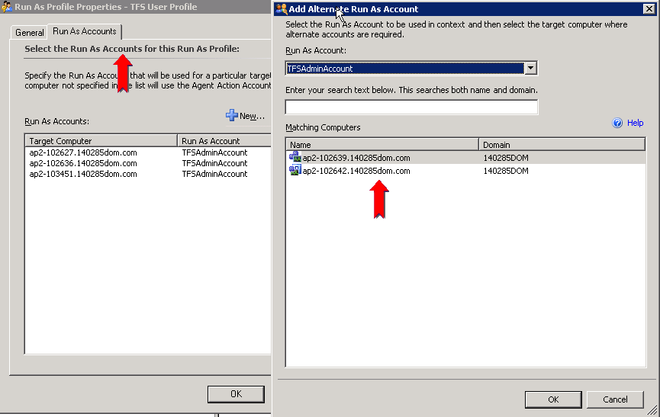

View of the Team Foundation Server MP Objects in the Operator Console.
After finishing the above mentioned steps, you should be able to see the MP objects in the Operator Console. Go to the Operator Console and click on the Monitoring pane.
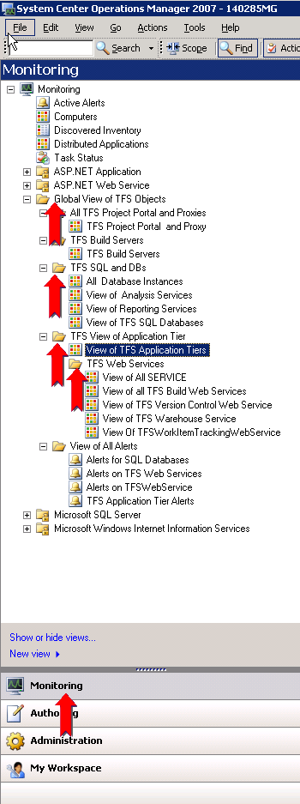
In the details pane, in the middle of the Operator Console, you can see the state views of the various Team Foundation Server Objects by navigating and clicking on them in the left pane. One such state view for the overall top node of the “application tier” is shown below. The figure below shows examples of states for monitored Team Foundation Servers.
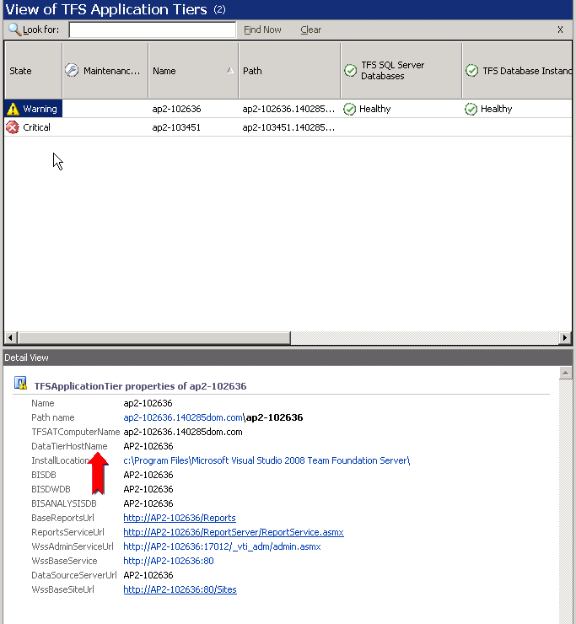

At this point, you are ready to start monitoring Team Foundation Servers in your network.

Install Best Practice Analyzer (BPA) for Team Foundation Server
The MP has the ability to run the BPA for Team Foundation Server as an Agent task. To enable this feature, the BPA for Team Foundation Server has to be installed on the default location on the Team Foundation Server application tier hosts. You should also create the directory C:\TEMP\TFSBPAOUTPUT on the machines where the BPA for Team Foundation Server has been installed. This is where the BPA tool will generate the results of the scan.

